 | Town of Essex - Information Systems  33 Talbot Street South Essex, ON N8M 1A8  Telephone: (519) 776-7336 Fax: (519) 776-8811

Title: Outlook – Scheduling Assistant

Created By: Sara Smith

Date: April 14, 2023

To use the Scheduling Assistant in Outlook, follow these steps:
- Open Outlook and create a new meeting invitation.
- In the meeting invitation, click on the "Scheduling Assistant" button located on the ribbon at the top of the window.
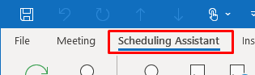
- The Scheduling Assistant window will appear, showing a calendar view of the proposed meeting time and the availability of attendees.
- To add attendees, click on the "Add Attendees" button at the top of the window and select the desired attendees from your address book or by typing in their email addresses.
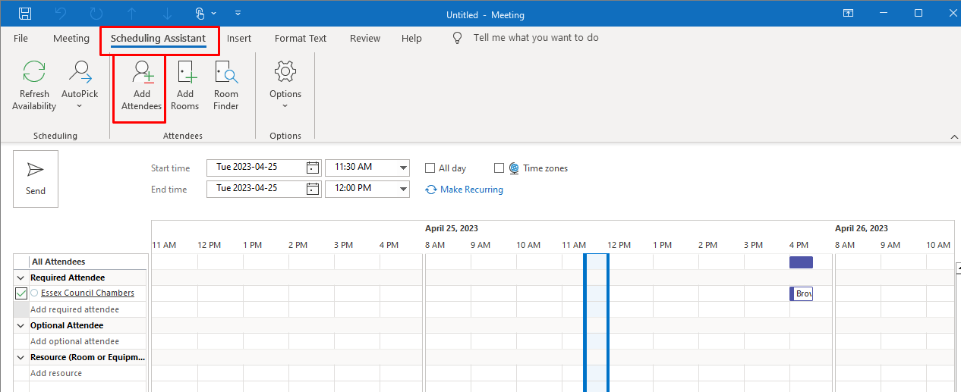
- To adjust the meeting time, simply drag and drop the proposed time slot in the calendar view to a different time.
- The availability of attendees will be indicated by their calendar status color-coded in the Scheduling Assistant window. If an attendee's status shows as "Busy," they may not be available for the proposed meeting time.
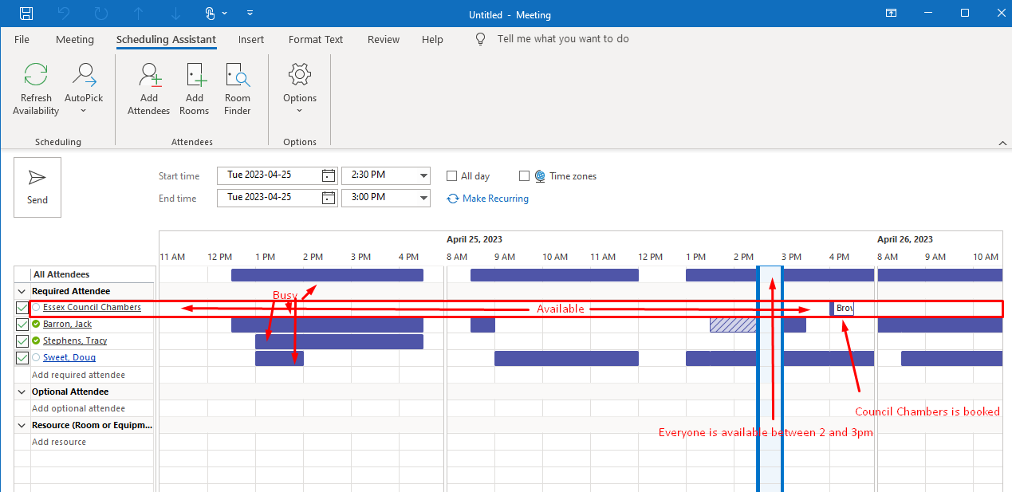
- Once you have selected a suitable meeting time that works for all attendees, click the "Send" button to send the meeting invitation to the attendees.
That's it! You have successfully used the Scheduling Assistant in Outlook to schedule a meeting with attendees.

